Localtunnel howto

Normally you run the ASP.NET MVC project and make HTTP requests to it on your machine via localhost:portnumber. Twilio needs to make HTTP requests to our project, however, and on Twilio servers localhost means their machine! To get around this, we create a temporary public URL through localtunnel. I've created localtunnel.bat that does this automatically; all you have to do is set it up as an external tool on Visual Studio by going to “Tools>External Tools...” and adding a new tool:

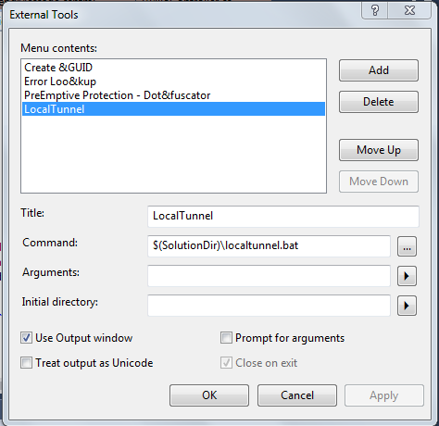

Then every time you run the Visual Studio project and want to interact with Twilio, also run the external tool.

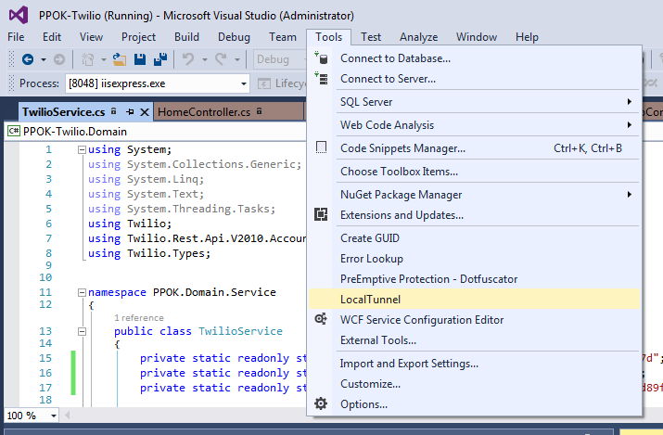

You can see localtunnel in action by accessing https://ppoktwilio.localtunnel.me/ in your browser. If you see the message “no active client for 'ppoktwilio', then you need to re-run localtunnel (it closes when the port stops being used).

For more information about localtunnel, see https://localtunnel.github.io/www/.

References:
https://localtunnel.github.io/www/
https://www.twilio.com/engineering/2011/06/06/making-a-local-web-server-public-with-localtunnel
http://www.hongkiat.com/blog/accessible-local-web-server/
http://stackoverflow.com/questions/4709014/using-custom-domains-with-iis-express/32744234#32744234

